Clinicians Gateway Problem List Feature July 2022

The Problem List is dynamic log which is available to record problems for a client.
- The Problem list is accessible by all clinicians who have access to the client according to security protocols.
- Problems may be added and ended by multiple, different staff over time
- Staff who add or end problems are automatically pre-populated into the Problem List
- Active problems are listed at the top of the chart
- End-dated problems are moved to the bottom of the chart
- Current problems will populate onto the Progress Note edit screen for reminders
- Availability to add specific problem codes will be governed by the staff type

Problem List

Number | Code | Description | Added By | Job Title/  Credential Level | Begin Date | End Date | Ended By | Job Title/  Credential Level
1

Example filled out: Problem List

Number | Code | Description | Added By | Job Title/  Credential Level | Begin Date | End Date | Ended By | Job Title/ Credential  Level
1 | F33.3 | Major Depressive  Disorder recurrent, severe with psychotic features | Name | Psychiatrist | 8/1/2022 | Current | Name | Psychiatrist
2 | F10.99 | Alcohol Use Disorder,  unspecified | Name | Clinical Social  Worker | 7/26/2022 | Current | Name | Clinical Social Worker
3 | I10. | Hypertension | Name | Primary Care  Physician | 7/25/2022 | Current | Name | Primary Care  Physician
4 | Z62.819 | Personal history of  unspecified abuse in childhood | Name | Clinical Social  Worker | 7/16/2022 | Current | Name | Clinical Social Worker
5 | Z59.02 | Unsheltered  homelessness | Name | Peer Support  Specialist | 7/1/2022 | Current | Name | Peer Support  Specialist
6 | Z65.9 | Problem related to  unspecified psychosocial circumstances | Name | Mental Health  Rehabilitation  Specialist | 7/1/2022 | 7/19/2022 | Name | Mental Health  Rehabilitation  Specialist

The Problem List may be accessed via the Action menu from the Client Facesheet or the Client Search Results
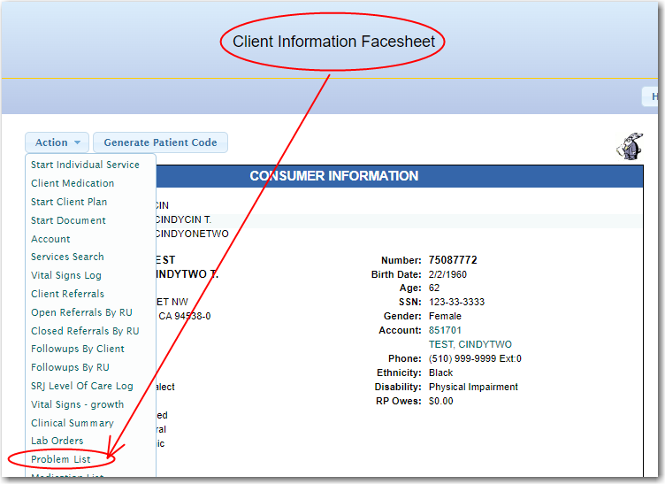

Client Search Results – Find the Problem List on the Action Menu

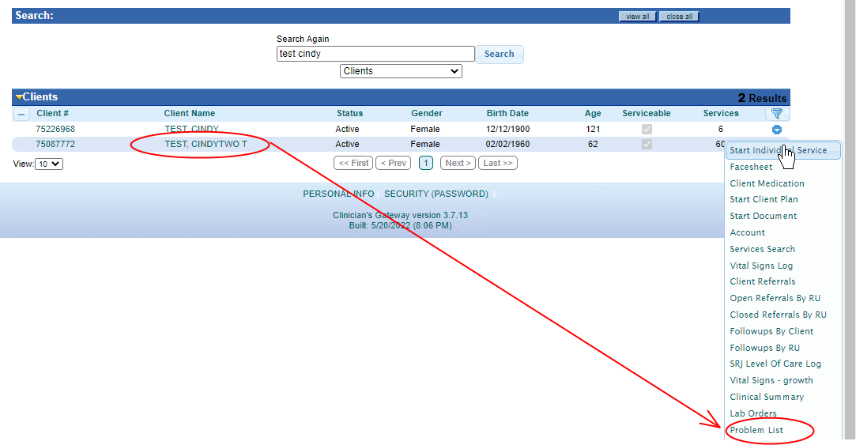

The Problem List would then show as it does below with the option of “Add Problem” & “End Date Problem”
